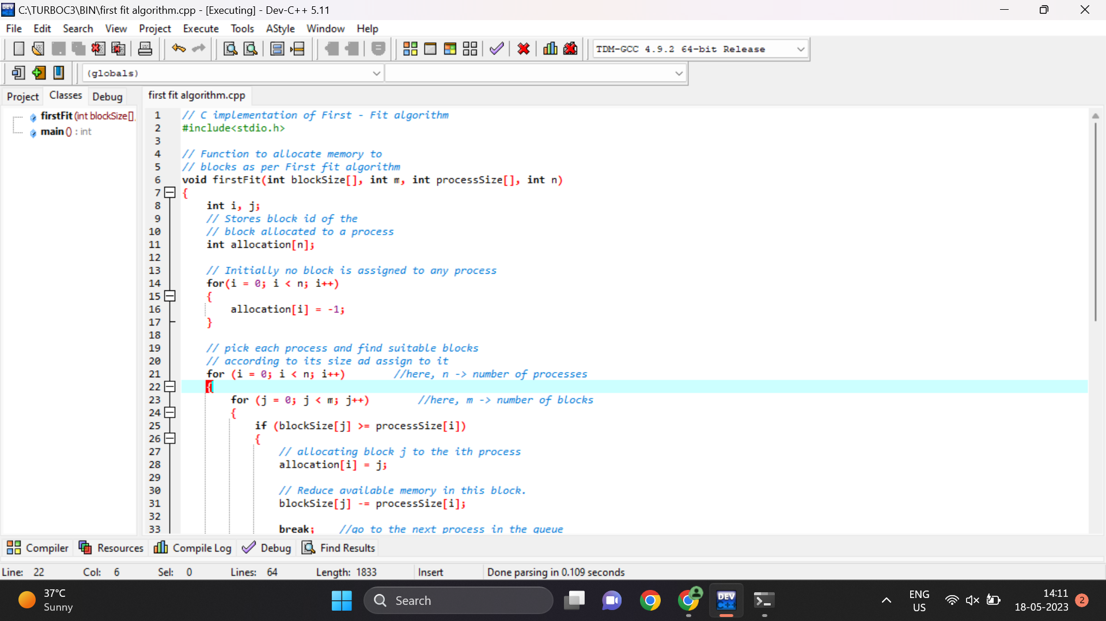



Output:

Process No. Process Size Block no.

1 212 2

2 417 5

3 112 2

4 426 Not Allocated

--------------------------------

Process exited after 0.03267 seconds with return value 0

Press any key to continue . . .